Architecture Document Team Assignment
Course: INFO 465
Team Members: Eric, Nishaaj, Latifa
- Member 1 – Cloud Architect
- Member 2 – Application & Database Architect
- Member 3 – QA & Documentation Support

1. Cloud Service Provider Selection(Nishaaj)

Selected Provider: Amazon Web Services (AWS)
Amazon Web Services (AWS) was selected as the cloud service provider due to its scalability, reliability, cost-effectiveness, and broad ecosystem of managed services. AWS provides global infrastructure across multiple availability zones, ensuring high availability and resiliency. Its pay-as-you-go pricing model supports flexible scaling based on demand, which makes it suitable for both development and production environments. Additionally, AWS integrates seamlessly with modern web application stacks and managed database services.

AWS Services Used in This Architecture
- EC2 – Hosts the application server
- RDS (MySQL) – Managed relational database service
- VPC – Network isolation
- Security Groups – Firewall control
- IAM – Access management

2. Application Design (Latifa)

Programming Language
JavaScript

Runtime Environment
Node.js

Application Framework
React (Frontend)

Middleware
Express.js (Backend)

API Design
RESTful API architecture
The application follows a client-server architecture. The frontend (React) communicates with backend RESTful APIs developed using Node.js and Express. API endpoints handle CRUD operations and interact with the MySQL database hosted on AWS RDS.

Port Configuration

3. Operating System & Virtual Servers

Operating System
Amazon Linux 2
Amazon Linux was selected because it is optimized for AWS, provides strong security patching, and supports Node.js environments efficiently.

EC2 Instance Configuration
- Instance Type: t3.micro
- vCPU: 2
- RAM: 1 GB
- Storage: 20 GB SSD
- Elastic IP for public access
This configuration supports development-level workloads while maintaining cost efficiency.
4. Database Design(Nishaaj)

Database Management System
MySQL (Hosted on AWS RDS or Oracle Apex)
MySQL was selected due to its compatibility with Node.js, scalability, strong community support, and cost-effectiveness.
The database design follows Third Normal Form (3NF) to ensure:
- Elimination of data redundancy
- Proper dependency management
- Referential integrity

Entities

Users
- UserID (Primary Key)
- Name
- Email
- Role

Projects
- ProjectID (Primary Key)
- Title
- Description
- CreatedDate

Submissions
- SubmissionID (Primary Key)
- UserID (Foreign Key)
- ProjectID (Foreign Key)
- SubmissionDate
All non-key attributes depend only on the primary key, satisfying 3NF requirements.
(Insert ER Diagram Here)

5. Network Architecture and Security

VPC Configuration
- 1 VPC
- 2 Public Subnets (for EC2 instances)
- 2 Private Subnets (for RDS database)
- Internet Gateway
- NAT Gateway for private subnet internet access
This configuration ensures redundancy across availability zones for high availability.

Security Groups Configuration

Application Server Security Group
Inbound Rules:
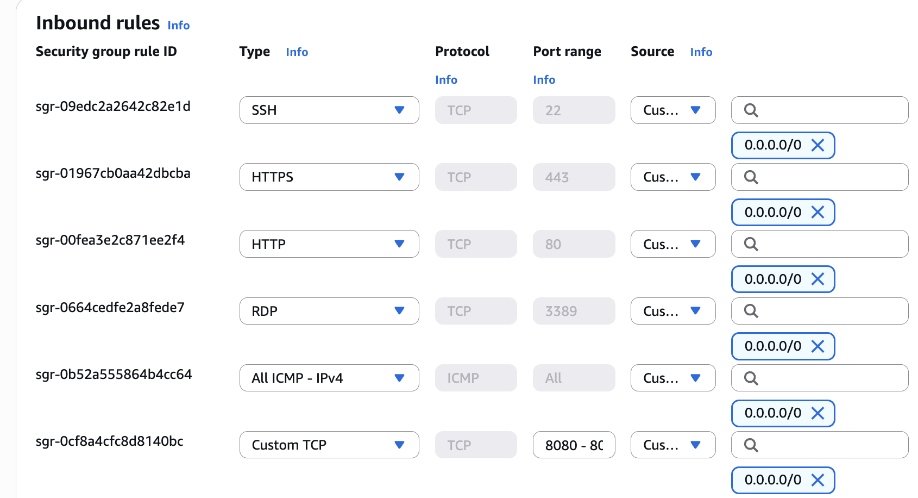
Outbound Rules:
- Allow all outbound traffic

Database Security Group
Inbound Rules:
- N/A
Outbound Rules:
- Restricted to required services
This layered approach ensures that the database remains isolated from public internet exposure.
(Insert Network Diagram Here)

6. Data Visualization Tool (Latifa)

Selected Tool: Google Colab with Python
Google Colab was selected as the data visualization environment due to its accessibility, cost-effectiveness, and integration with Python’s powerful data analysis libraries. Colab is cloud-based, requires no local installation, and is free to use, making it highly scalable for academic and startup environments.

Functionality and Features
Using Python libraries such as Pandas, Matplotlib, Seaborn, and Plotly, the system can generate interactive and customizable dashboards. These libraries allow advanced statistical analysis, real-time filtering, and dynamic visualizations.

AI and Data Integration Capabilities
Python integrates seamlessly with machine learning frameworks such as TensorFlow and Scikit-learn. This allows future implementation of predictive analytics, anomaly detection, and automated insights.

Team Familiarity and Ease of Use
The team has prior experience using Python for data analysis, which reduces the learning curve and improves development efficiency.

Cost and Scalability
Google Colab is free and cloud-based, eliminating infrastructure costs. It can scale by integrating with Google Cloud services if needed for production-level deployment.
Using Python-based visualization enables flexibility, customization, and advanced analytical capabilities beyond traditional dashboard tools.

7. Testing and Quality Assurance (Nishaaj)

Unit Testing (Validate Individual Components/Modules)

Scope
Unit tests verify single classes/functions/modules in isolation:
- Business logic (rules, validations, calculations)
- Controllers/handlers (with mocked dependencies)
- Service-layer methods
- Utility modules
- Data-access logic using mocks/fakes (not real DB)

Practices
- Arrange–Act–Assert structure; tests are readable and deterministic.
- Mock external dependencies (DB clients, message brokers, third-party APIs).
- Cover edge cases: null/empty inputs, boundary conditions, invalid states, idempotency behavior.
- Contract-based assertions: validate outputs and side effects (events emitted, logs/metrics increments if applicable).

Quality Gates (CI)
- Run on every PR and merge to main.
- Enforce:
  - Minimum coverage thresholds (team-defined; often higher for core business logic than UI).
  - No flaky tests: failures block merge; quarantining requires ticket + owner.
  - Optional but strong: mutation testing on critical modules (proves tests would fail if logic breaks).

Developer Workflow
- Tests written alongside code in the same PR.
- Definition of Done includes unit tests for:
  - New/changed business logic
  - Bug fixes (repro test first, then fix)

Integration Testing (Validate Modules/Services Working Together)

Scope
Integration tests validate real interactions across boundaries:
- Service ↔ database (real schema + migrations)
- Service ↔ cache
- Service ↔ message queue/event bus
- Service ↔ service (internal APIs)
- Service ↔ cloud services (object storage, secret manager) using either:
  - ephemeral real resources in a test account, or
  - vetted emulators where appropriate

Test Types to Include
- Database integration tests
  - Validate schema migrations, constraints, indexes, query correctness.
  - Ensure transactional behavior and rollback semantics.
- API integration tests
  - Validate routing, auth middleware, serialization, error handling.
- Contract tests (highly recommended)
  - If you have multiple services, use consumer-driven contracts to ensure API compatibility without requiring full end-to-end runs for every change.
- Event/message flow tests
  - Validate idempotency keys, retry behavior, dead-letter handling, and ordering assumptions.

Environment Strategy
- Use ephemeral test environments per PR when feasible:
  - Spin up containers/services via IaC templates (or compose-equivalent).
  - Use short-lived DB instances migrated from scratch.
- Maintain a persistent Integration environment (shared) for nightly broader runs.

Data Strategy
- Seed test data via:
  - migrations + fixtures
  - factory builders
  - synthetic datasets (no real PII)
- Mask/anonymize any copied production-like data if ever used (prefer synthetic).

CI Scheduling
- PR-level integration tests: “fast integration” subset (minutes, not hours).
- Nightly integration suite: broader coverage, includes heavier scenarios.

End-to-End Testing (Validate Full User Journeys)

Scope
E2E tests validate the system as a user experiences it, across:
- UI (web/mobile) ↔ API ↔ database
- Auth flows (login, token refresh, logout)
- Critical business workflows (create/update/approve/purchase/etc.)
- Role-based access control checks in real flows
- Observability hooks (key logs/metrics/traces appear)

What We Test (Keep It Small but Powerful)
Focus on critical path journeys:
- Happy path for top workflows
- One or two high-value negative paths (permission denied, validation errors)
- One resilience path (retry behavior, graceful degradation if a downstream is unavailable)
Avoid exploding into thousands of E2E tests—most permutations belong in unit/integration tests.

Execution
- Run E2E against a Staging environment that mirrors production:
  - same network patterns (private subnets, gateways)
  - same IAM patterns (least privilege)
  - same deployment type (containers/serverless)
  - same feature flags strategy
- Use test accounts/roles that reflect real RBAC groups.

Release Gates
- E2E suite must pass before:
  - release candidate promotion to production
  - major infra changes
- For faster release:
  - run smoke E2E on every deployment
  - run full E2E nightly and pre-release

8. Authentication and Authorization
The application will remain open-access during development as specified in the assignment.
Defined Roles:
- Student
- Administrator

9. Team Contribution Summary (Latifa)
Member 1 – Cloud Architect
Designed AWS infrastructure, VPC layout, subnet structure, and security group configuration.
Member 2 – Application & Database Architect
Defined application stack, REST API design, database schema, and testing strategy.
Member 3 – QA & Documentation Support
Reviewed architecture design, validated testing strategy, formatted documentation, and assisted in GitHub collaboration.
Challenges faced included coordinating schedules and aligning design decisions. These were resolved through structured GitHub commits and collaborative documentation review.

10. GitHub Collaboration Proof
(Screenshot inserted here showing document uploaded to team GitHub repository)

- ER Diagram
- Network Architecture Diagram
- GitHub Screenshot
Then export as PDF or DOCX.

